Project requirements

1. Object oriented elements that you write the code for:
2. Classes (Tetramino.java, TetraminoGenerator.java, Tetris.java etc.):

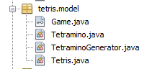

1. Subclasses (ControllerTetrisGame.java):

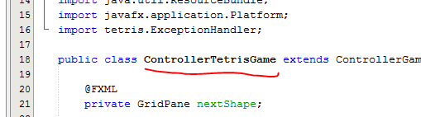

1. Abstract class (ControllerGameSession.java):

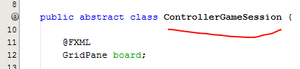

1. Interface (Game.java):

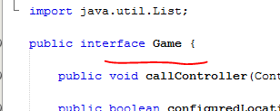

1. Code elements:
2. Collection:

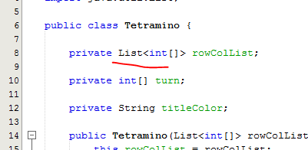

1. Exception Handling:

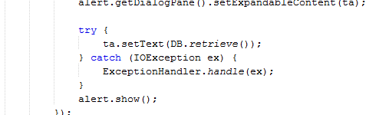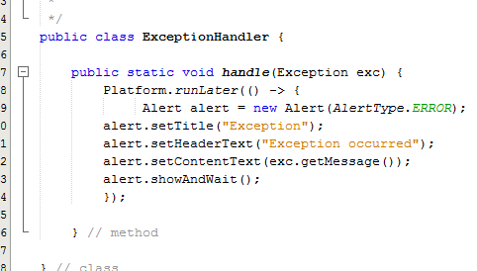

1. Model:

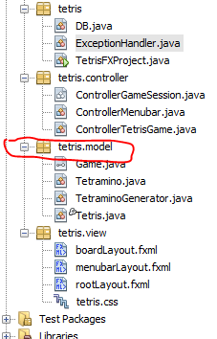

1. Scene:

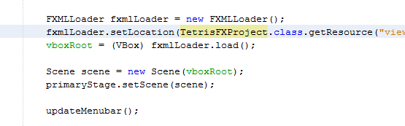

1. About:

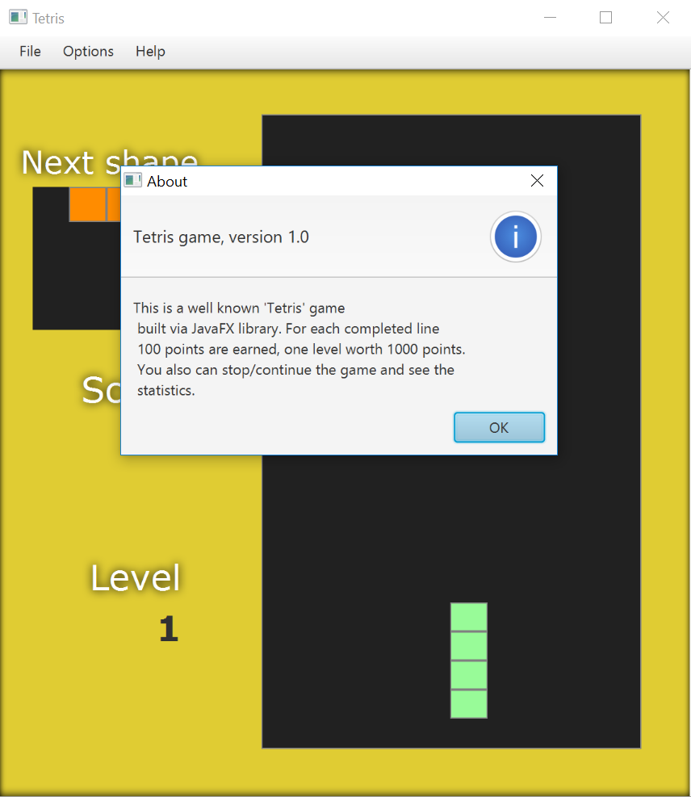

1. Load/save data:

